40.20: 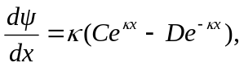
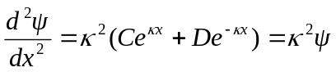
for all constants and 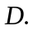 Hence is a solution to Eq. (40.1) for
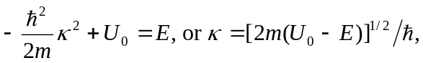
and is real for 